LUBANGAKENE JONATHAN
BSC. COMPUTER SCIENCE
2023-B291-13195

1. Maze Problem
- Start state: This is the initial position of the agent in the maze, typically represented by the coordinates of the starting cell (e.g., (0, 0)).
- Goal state: This is the final position the agent needs to reach to solve the maze, represented by the coordinates of the exit cell.
- Possible actions from each cell: From any given cell, the possible actions are to move to an adjacent cell. This can include moving up, down, left, or right, provided that the move does not go outside the grid boundaries or into a blocked cell (a wall).
- A valid solution path using BFS (Breadth First Search): A valid solution path is a sequence of moves (states) from the start state to the goal state. A Breadth-First Search (BFS) algorithm finds the shortest path in an unweighted graph, which a maze can be modelled as. BFS explores all the nodes at the present depth level before moving on to the nodes at the next depth level. It does this by using a queue to keep track of the nodes to visit. The first path found by BFS is guaranteed to be the shortest path.

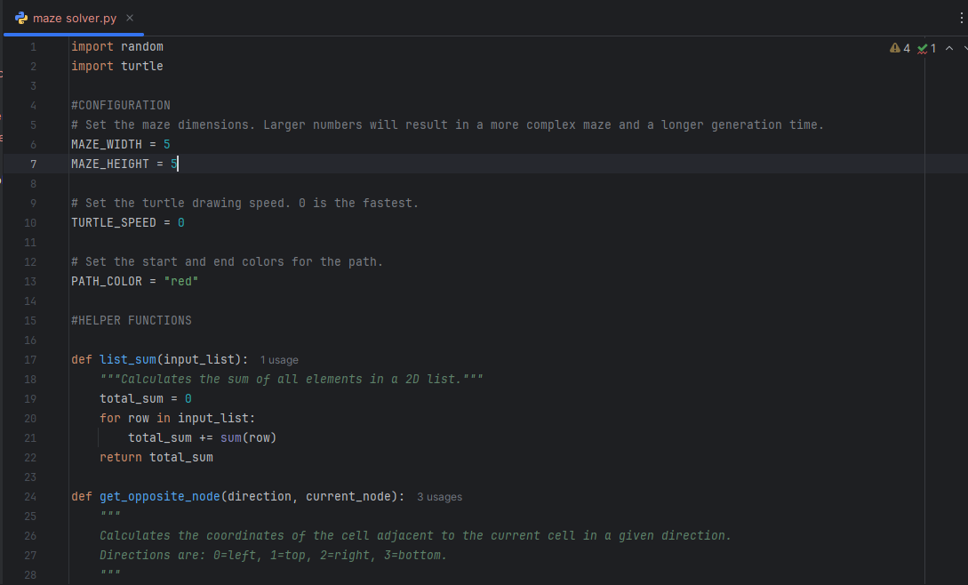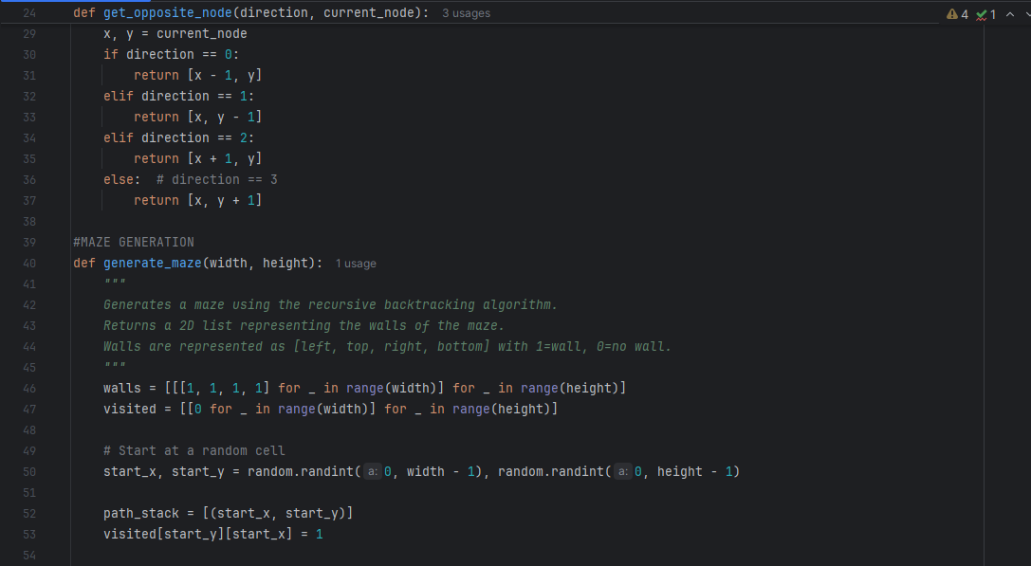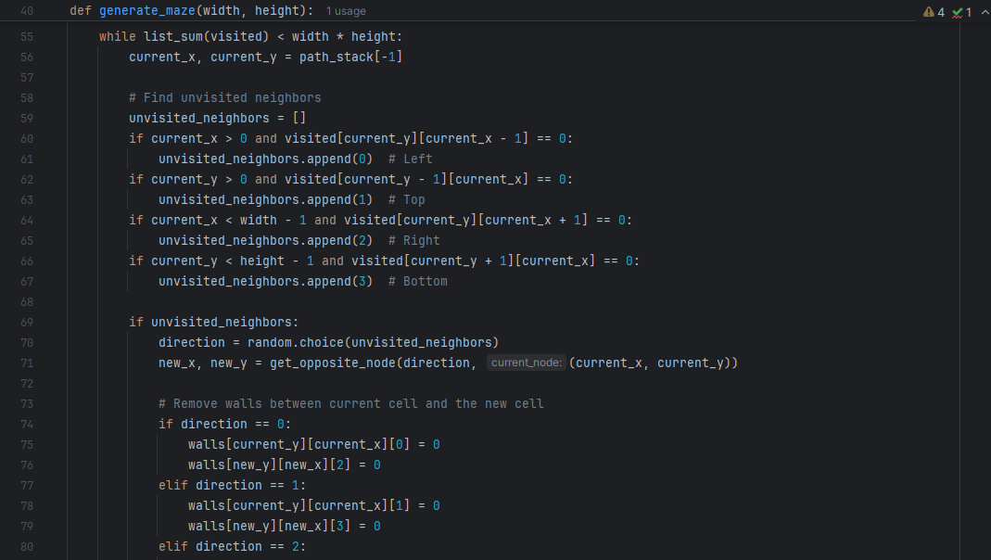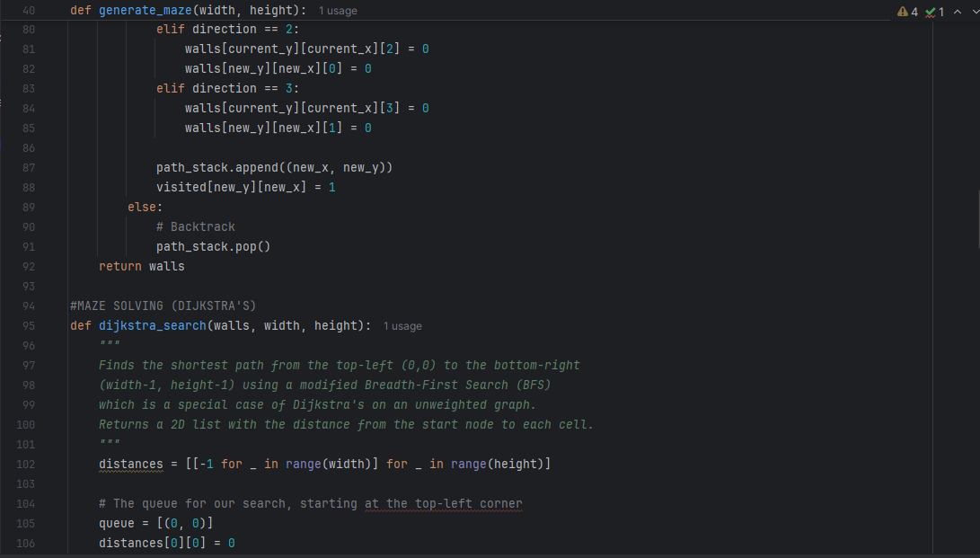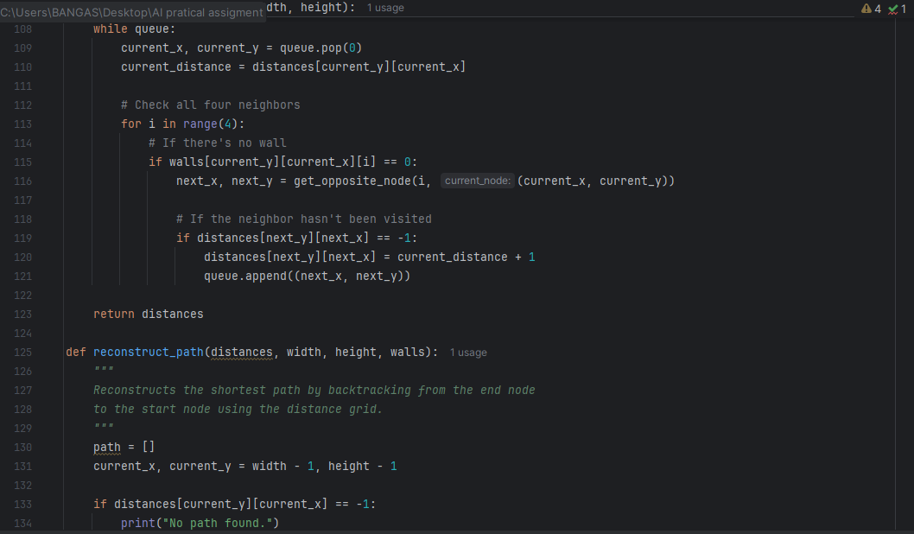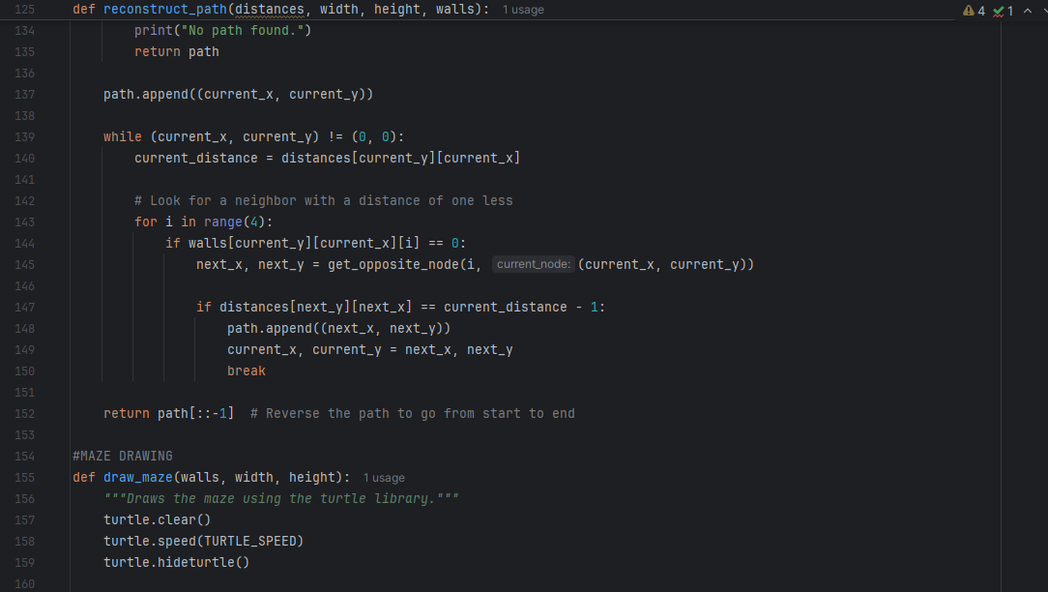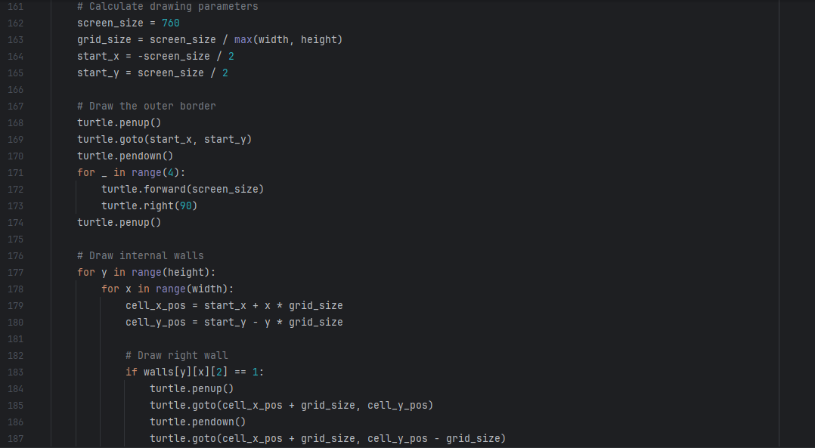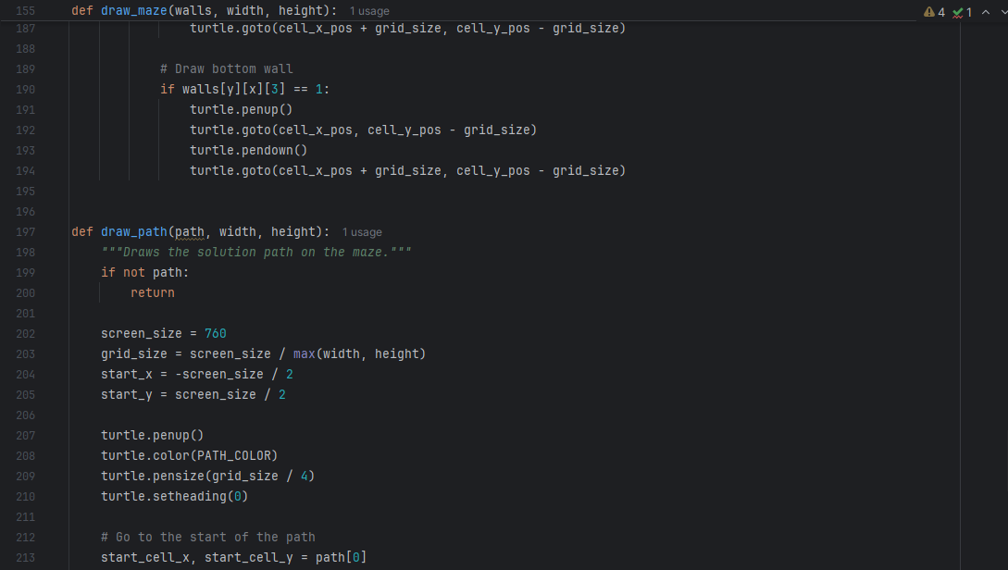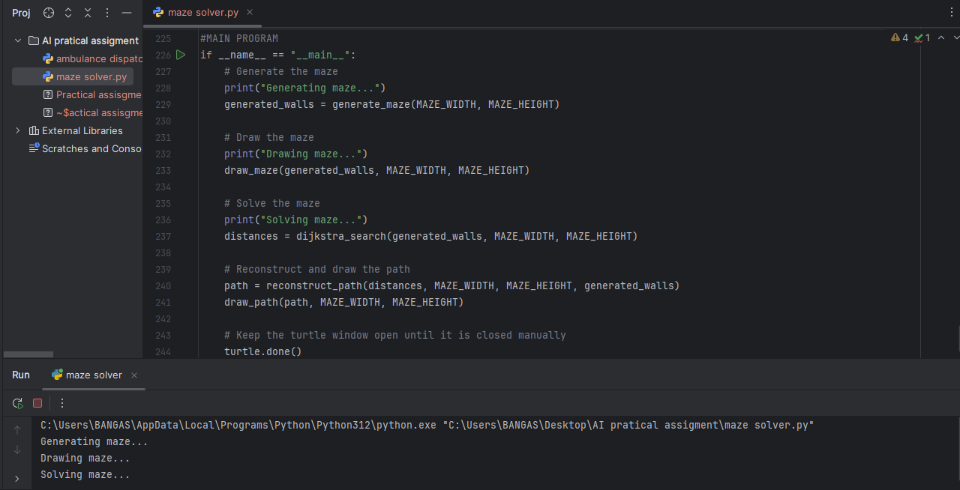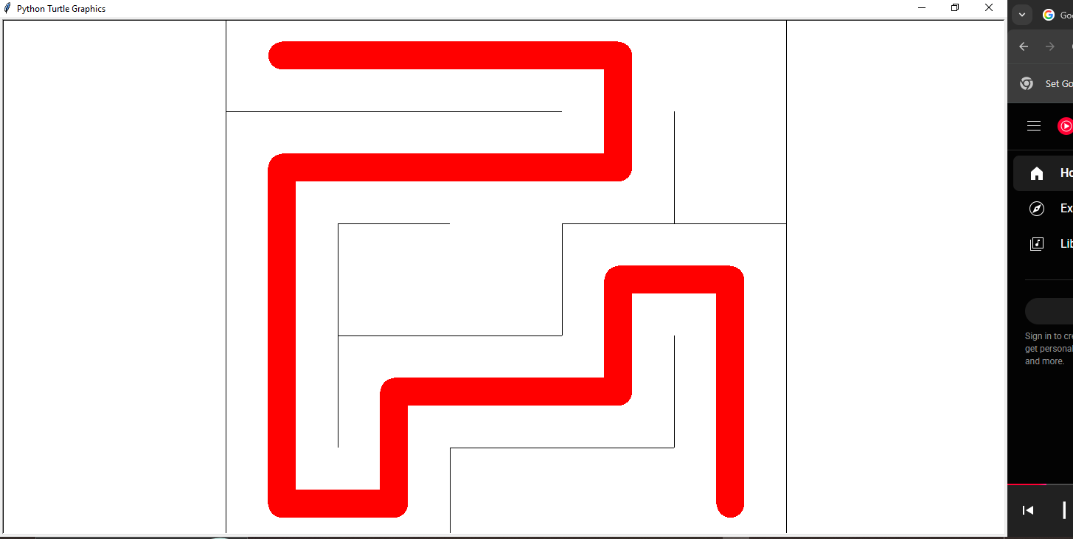

2. AI System for Ambulance Dispatch
- State space: The state space represents all possible configurations of the problem. In this case, a state can be defined as the current locations of all ambulances and the locations of all active emergency calls. For example, a state might be represented as (ambulance_1_location, ambulance_2_location and call_1_location, call_2_location).
- Actions: An action is a move that transitions the system from one state to another. The primary action is assigning an available ambulance to an emergency call and dispatching it. Possible actions can include move North, South, East, West or move to an adjacent intersection.
- Goal: The goal is to successfully dispatch ambulances to all emergency calls in the most efficient manner, which is typically to minimize the total response time for all calls.
- Path cost: The path cost is the measure of the efficiency of a sequence of actions. A suitable path cost would be the total time taken for all ambulances to reach their assigned destinations. This can be calculated based on the distance between the ambulance and the emergency location, factoring in traffic conditions. Minimizing this cost is the objective of the search.
A suitable search strategy for this problem is an Informed Search algorithm, specifically A* Search.
Justification:
A* Search is a powerful choice because it's a best-first search algorithm that uses a heuristic function to guide its search. It finds the optimal path (the one with the lowest cost) from a start node to a goal node.
A* uses the following cost function:
f(n) = g(n) + h(n) where;
- g(n) is the cost from the initial state to the current state n (the actual time elapsed for the dispatches made so far).
- h(n) is a heuristic estimate of the cost from the current state n to the goal state (e.g the estimated time for the remaining ambulances to reach their assigned calls based on the straight-line distance or a simplified traffic model).
Why A* is a good fit:
- Optimality: A* guarantees finding the optimal solution (the dispatch plan that minimizes the total response time) if the heuristic is admissible (never overestimates the cost to the goal). A good admissible heuristic could be the sum of the straight-line distances for all unassigned calls.
- Efficiency: Unlike uninformed search algorithms like BFS or DFS, A* is more efficient because it uses the heuristic to intelligently explore only the most promising paths, avoiding the need to explore large, irrelevant parts of the state space. This is crucial for real-time applications like ambulance dispatch, where a quick and optimal decision is needed.

